- Access the SERS Help Desk website by clicking on the link to the ticketing system. This link will be available at the upper left corner of all SERS screens:

Need Assistance? Open a ticket with SERS Help Desk

- Review the available categories on the SERS Help Desk landing page and select the category that applies to your inquiry. The three available categories include “SERS Policy Assistance”, “SERS Functionality Assistance”, and “Division of Earnings and Business Services”:

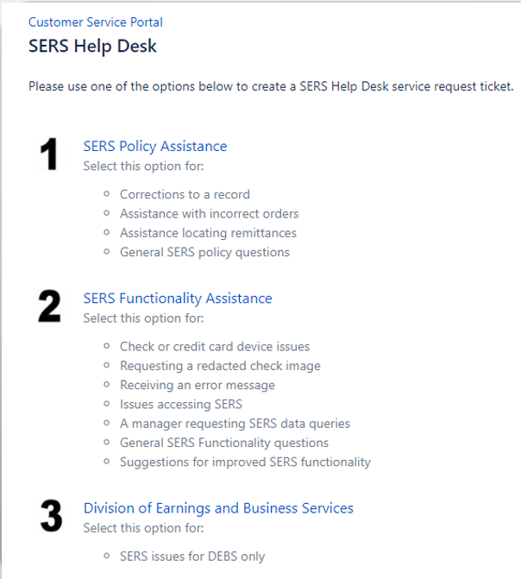

- Fill out the selected inquiry form. This form has a section for a “Description” of the inquiry and an optional section for attachments. After completing the form you will click on the “Create” button to open the help desk ticket:

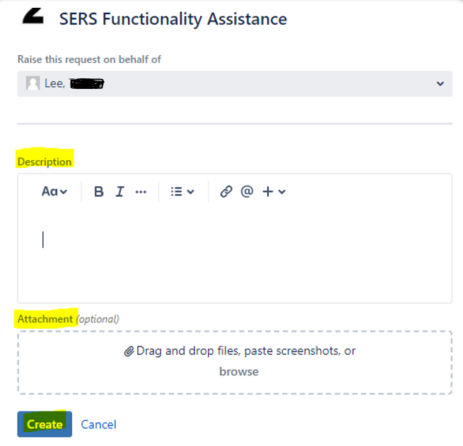

After completing the three steps above, the inquiry will be sent directly to the SERS help desk team.

