 | Konica Minolta Bizhub  How to Use a Certification Stamp Setting with WorkTrack
NOTE: These steps will need to be followed EACH time a user chooses to add THEIR programmed certification stamp to a WorkTrack Scan.

- Select the WorkTrack Button. | 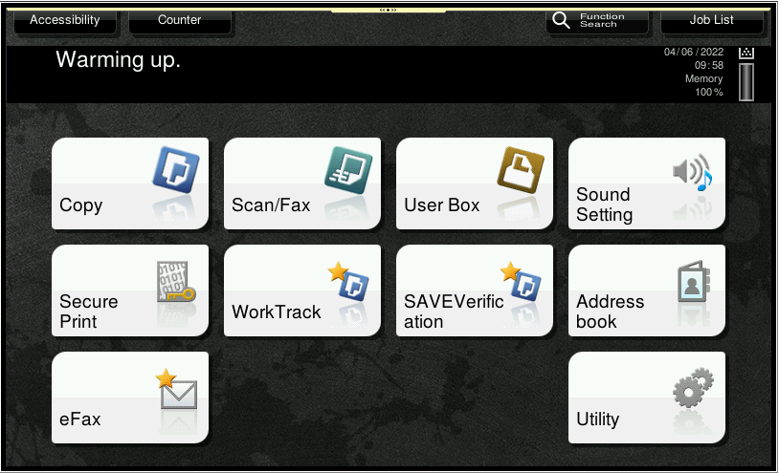
- Select the Application Button. | 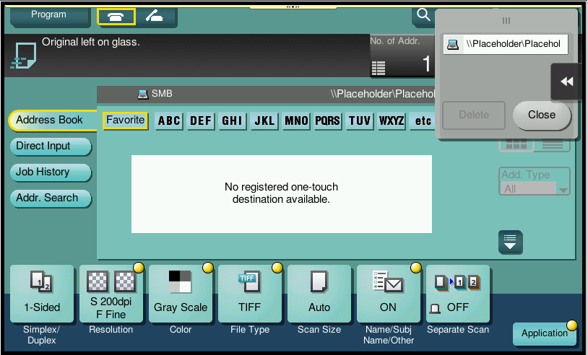
- Press the Right arrow or move the slide until you can see Header/Footer. Select Header/Footer. | 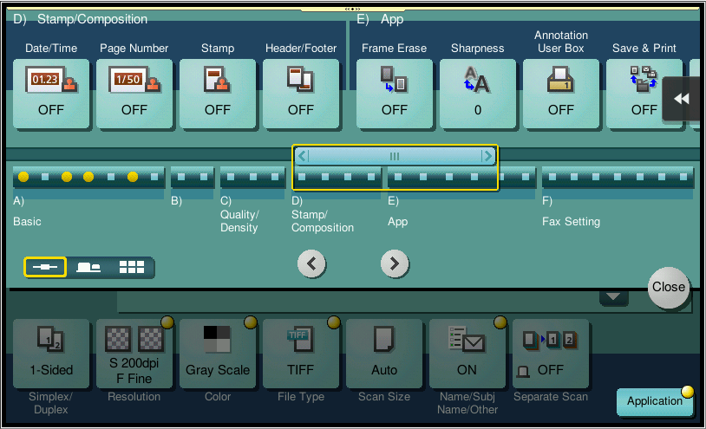
- Select ON and select the Header/Footer you want to use then select OK. | 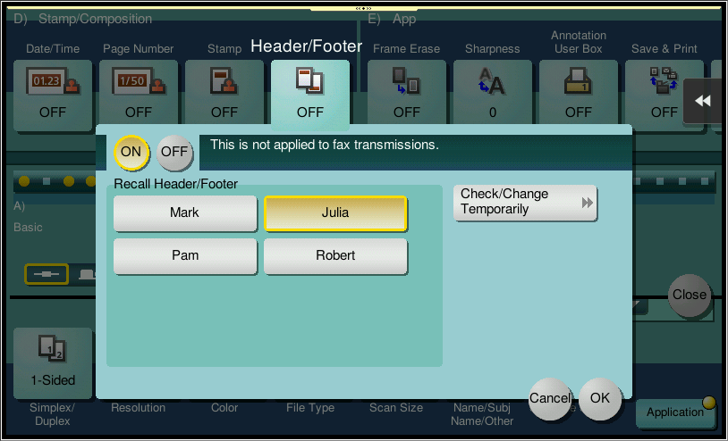
- Select Close. | 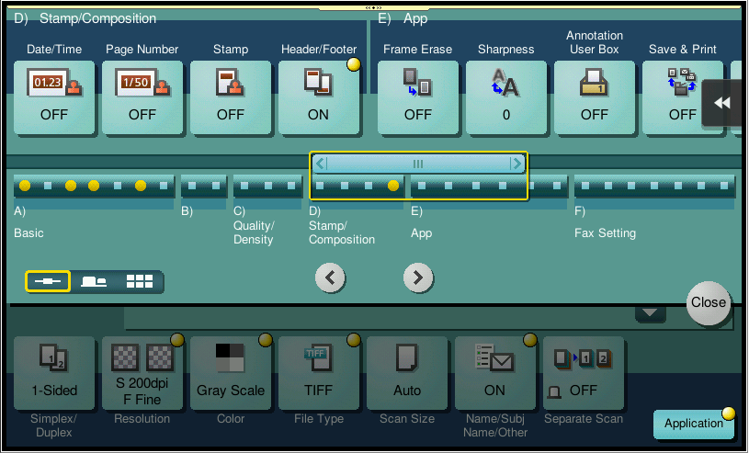
6. Press Start Button on the Bizhub to start WorkTrack scanning.

